1. 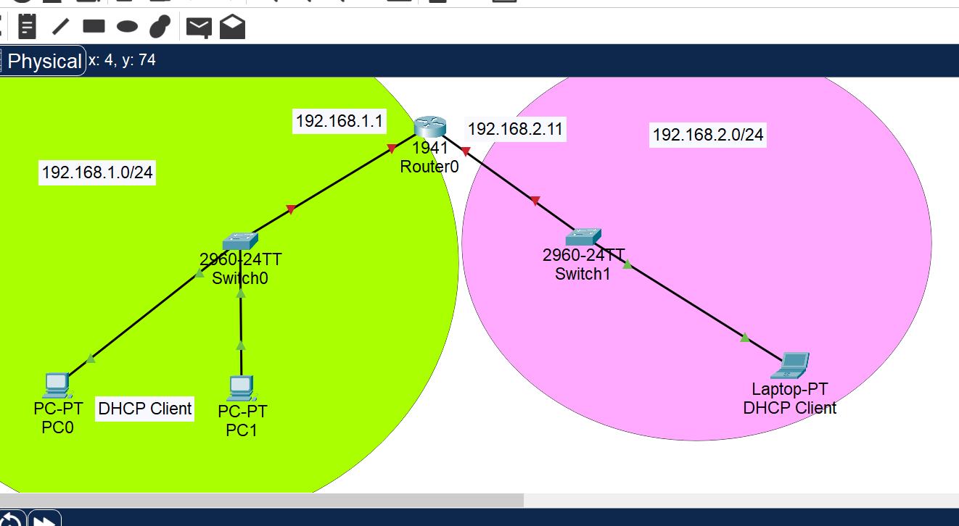Design a network according to above figure.
2. Make hostname yourname and password yourname123
3. Make DHCP in the router for both 192.168.1.0/24 and 192.168.2.0/24 network.
4. Configure telnet in Router .